**EXPERIMENT NO. 06**

|  |
| --- |
| NAME: Ayush Vinod Upadhyay  ROLL NO: I025  SAP ID: 60003220131  BRANCH: Information Technology  BATCH: 1 |

FIFO

#include <stdio.h>

int main()

{

    int frames, pages, pageFaults = 0;

    printf("Enter the number of frames: ");

    scanf("%d", &frames);

    printf("Enter the number of pages: ");

    scanf("%d", &pages);

    int incomingStream[pages];

    printf("Enter the page reference sequence:\n");

    for (int i = 0; i < pages; ++i)

    {

        scanf("%d", &incomingStream[i]);

    }

    int temp[frames];

    for (int m = 0; m < frames; m++)

    {

        temp[m] = -1;

    }

    printf("Page Reference Sequence: ");

    for (int i = 0; i < pages; ++i)

    {

        printf("%d ", incomingStream[i]);

    }

    printf("\n");

    int m, n, s;

    for (m = 0; m < pages; m++)

    {

        s = 0;

        for (n = 0; n < frames; n++)

        {

            if (incomingStream[m] == temp[n])

            {

                s++;

                pageFaults--;

            }

        }

        pageFaults++;

        if ((pageFaults <= frames) && (s == 0))

        {

            temp[m] = incomingStream[m];

        }

        else if (s == 0)

        {

            temp[(pageFaults - 1) % frames] = incomingStream[m];

        }

        printf("Frames at stage [%d]: ", m + 1);

        for (int i = 0; i < frames; ++i)

        {

            if (temp[i] == -1)

            {

                printf("- ");

            }

            else

            {

                printf("%d ", temp[i]);

            }

        }

        printf("\n");

    }

    printf("Total Page Faults: %d\n", pageFaults);

    return 0;

}

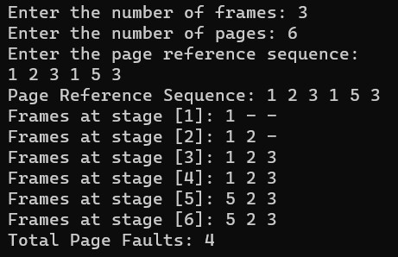

LRU

#include <stdio.h>

#include <stdbool.h>

int main()

{

    int capacity, pages, pageFaults = 0;

    printf("Enter the number of frames: ");

    scanf("%d", &capacity);

    printf("Enter the number of pages: ");

    scanf("%d", &pages);

    int incomingStream[pages];

    int indexes[capacity];

    int set[capacity];

    bool pagePresent[capacity];

    for (int i = 0; i < capacity; i++)

    {

        indexes[i] = -1;

        pagePresent[i] = false;

    }

    printf("Enter the page reference sequence:\n");

    for (int i = 0; i < pages; i++)

    {

        scanf("%d", &incomingStream[i]);

    }

    printf("Page Reference Sequence: ");

    for (int i = 0; i < pages; i++)

    {

        printf("%d ", incomingStream[i]);

    }

    printf("\n");

    for (int i = 0; i < pages; i++)

    {

        if (pagePresent[incomingStream[i]])

        {

            // Page is already in memory, do nothing

        }

        else

        {

            if (pageFaults < capacity)

            {

                int emptySlot = -1;

                for (int j = 0; j < capacity; j++)

                {

                    if (!pagePresent[j])

                    {

                        emptySlot = j;

                        break;

                    }

                }

                if (emptySlot != -1)

                {

                    set[emptySlot] = incomingStream[i];

                    pagePresent[emptySlot] = true;

                    indexes[incomingStream[i]] = i;

                }

            }

            else

            {

                int minIndex = pages + 1;

                int victimPage;

                for (int j = 0; j < capacity; j++)

                {

                    if (indexes[set[j]] < minIndex)

                    {

                        minIndex = indexes[set[j]];

                        victimPage = j;

                    }

                }

                pagePresent[victimPage] = false;

                set[victimPage] = incomingStream[i];

                pagePresent[victimPage] = true;

                indexes[incomingStream[i]] = i;

                pageFaults++;

            }

        }

    }

    printf("Total Page Faults: %d\n", pageFaults);

    return 0;

}

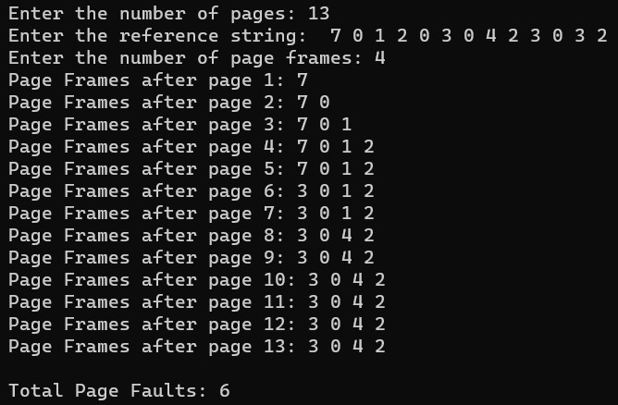

**BOOKS AND WEB RESOURCES:**

* "Operating System Concepts" by Abraham Silberschatz, Peter B. Galvin, and Greg Gagne
* "Operating Systems: Three Easy Pieces" by Remzi H. Arpaci-Dusseau and Andrea C. Arpaci-Dusseau

* GeeksforGeeks
* Tutorialspoint

**Conclusion:**

In this study, we implemented and compared FIFO and LRU page replacement algorithms in C language. Both algorithms were tested with the same reference string "1 2 3 4 1 2 5 1 2". The FIFO algorithm, replacing the oldest page, and the LRU algorithm, replacing the least recently used page, both resulted in 9 page faults. These findings highlight the importance of considering specific application requirements and access patterns when choosing the appropriate page replacement strategy.